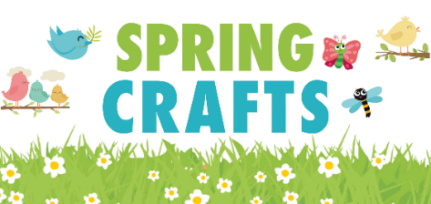 13th February 2026
Dear Parents/Carers,
Crafternoons – Parent sharing craft sessions in Nursery classes on Friday 20th March.
We are delighted to be able to invite you to join your child in class for a Spring themed craft afternoon on Friday 20th March for Nursery children. You are welcome to join your child’s class from 2.15pm.
Please let us know if you will be able to join us by returning the slip below, to your child’s class teacher, by Friday 13th March. If you have more than one child at our school, please return a slip for each and then the class teachers will know to expect you.
To ensure that we take our duty of care responsibly, and all visitors will be issued with a visitor label at the office. We would also remind visitors to use adult toilets, whilst on site (and not the children’s!). An adult toilet can be found near our front reception office.
Once you have finished your craft activities, you are welcome to leave from 3pm onwards. Please make sure that you let the class teacher know that your child is leaving.
We do hope that you can join us!
Mrs. Julia Miles
Principal
----------------------------------------------------------------------------------------------------------------------------
Please return slip to your child’s class teacher by Friday 13th March 2026.
I am looking forward to joining you for a craft morning or afternoon on Friday 20th March 2026.
Name:__________________________________________
Child’s name:_______________________________________
Class:____________________________

