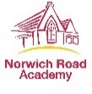

Friday 6th February 2026
Norwich Road Academy is hosting an Easter Egg Hunt for children in:-
Reception
Year 1
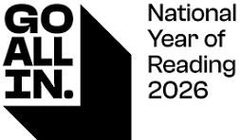

Year 2

On Monday 23rd March 2026
From 3.15 - 3.45
KS1 playground

Collect 10 different hidden stamps and claim a prize.

Tickets are £3.00 each and every child who enters will win an Easter Egg.
As 2026 is the ‘National Year of Reading’ every child who enters will also receive a Norwich Road Academy bookmark designed by our Year 6 House Captains.
To help us keep your children safe, children MUST be accompanied and supervised by an adult.
Please buy your ticket by Friday 6th March to ensure the academy can get enough prizes.

TICKETS WILL NOT BE SOLD ON THE DAY
------------------------------------------------------------------------------------------------------------------------------------------------------------
Easter Egg Hunt for Nursery, Reception, Year 1 and Year 2 

Name: _____________________________ Class: ___________________________________

Allergy information: ___________________________________________________________
I will be able to attend with my child: YES / NO (delete as appropriate)
or
Name of adult attending with child : _______________________________________________

Your child will be given a stamp collecting sheet on Monday 23rd March 2026

