12th January 2026

Dear Parents/Carers,

Library Visit on Tuesday 10th February

2026 is the National Year of Reading organized by the Department for Education and the National Literacy Trust. It is created to help children and adults in the UK enjoy reading more. Everyone is encouraged to explore all kinds of stories, books, comics, magazines, websites, and even audiobooks, with the theme ‘Go All In’. Look out for fun events and challenges throughout the year organized by libraries and local communities.
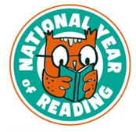

To help our children develop a love of reading we will be visiting Thetford Library together. We will be walking to the library where we will have a story time session with a librarian and the children will then have time to explore the library itself. This will be from approximately 9.45 am – 11 am. If your child does not currently have a library card and you would like them to have one, please complete the attached form and return to school by Friday 31st January. We will pass these onto the library and the children will then be given their card when we visit. We will not be able to process forms returned after this date.

If you are able to accompany us on this visit, please speak to a member of staff and, as always, if you have any questions, please speak to a member of the team.

Thank you
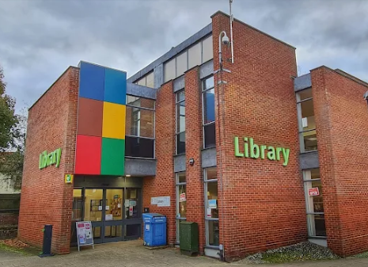

Mrs Rebecca Sangster
Butterflies teacher

